**Practical 11**

**Write a Python function to find the roots of a quadratic equation.**

a,b,c=map(int,input('enter a, b & c :').split(' '))  
d = (b**2) - (4*a*c)  
sol1 = (-b-(d**0.5))/(2*a)  
sol2 = (-b+(d**0.5))/(2*a)  
print('solutions are')  
print('sol1 = ',sol1)  
print('sol2 = ',sol2)

Output:-

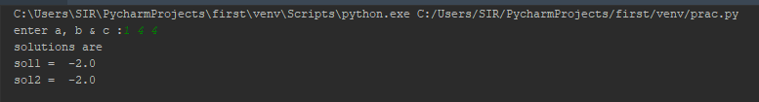

**Practical 12**

**Write a Python function to evaluate factorial.**

def fact(a):  
 res=1  
 while a>=1:  
 res*=a  
 a=a-1  
 return res  
  
a=int(input('Enter the number : '))  
print('Factorial value of ',a,' is : ',fact(a))

Output:-



**Practical 13**

**Write a Python function to test whether a given number a is prime or not.**

def prime(a):  
 flag = 0  
 if a>1:  
 for i in range(2, a // 2):  
 if a%i==0:  
 flag = 1  
 #print(a,' is not prime')  
 break  
 if flag == 1:  
 print(a, ' is not prime')  
 else:  
 print(a,'is prime')  
  
a=int(input('Enter a : '))  
prime(a)

Output:-



**Practical 14**

**Write a Python function to generate Fibonacci series till given number.**

def fibo(n):  
 a=0  
 b=1  
 if n > 1:  
  
 print(a);  
 print(b);  
 for i in range(2,n):  
 c=a+b  
 a=b  
 b=c  
 print(c)  
 else:  
 print("Enter correct no.")  
  
n=int(input('how many numbers you want : '));  
fibo(n)

Output:-

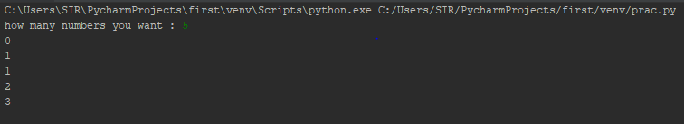

# Practical 15

**A python program that helps to know the effects of slicing operations on an array.**

ash = input("Enter the list: ").split()  
print(ash[::3])  
print(ash[::-1])  
print(ash[0:4:-1])  
print(ash[:-7])  
print(ash[:2])  
print(ash[2:])

Output:-

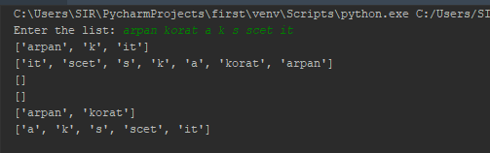

# Practical 16

**A python program to sort the array elements using bubble sort technique.**

n=int(input('enter the total value'))  
arr=[]  
for i in range(0,n) :  
 print('enter arr[',i+1,']' )  
 k=int(input())  
 arr.append(k)  
  
print('array before sorting',arr)  
for i in range(0,n):  
 for j in range(i+1,n):  
 if arr[i]>arr[j]:  
 temp=arr[i]  
 arr[i]=arr[j]  
 arr[j]=temp  
  
print('array after sorting',arr)

Output:-

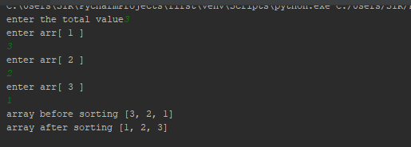

**Practical 17**

**A python program to search for the position of an element in an array using index( ) method.**

n=int(input('enter the total value : '))  
arr=[]  
for i in range(0,n) :  
 print('enter arr[',i+1,']' )  
 k=int(input())  
 arr.append(k)  
  
a=int(input('Enter the number of which you want to know the position :'))  
print('Index of ',a,'is :',arr.index(a))

Output:-

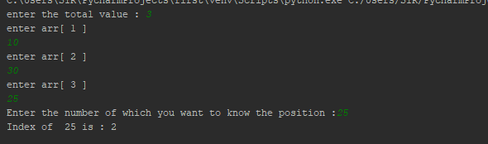

**Practical 18**

**A python program to accept two matrices and find their product.**

def matrix(row, column):  
 p = []  
 print('Enter elements row wise')  
 for i in range(row):  
 q = []  
 for j in range(column):  
 k = int(input())  
 q.append(k)  
 p.append(q.copy())  
 q.clear()  
 return p  
  
print("1st matrix:")  
i, j = map(int, input("enter row and column=").split(" "))  
a = matrix(i, j)  
print("2st matrix:")  
i, j = map(int, input("enter row and column=").split(" "))  
b = matrix(i, j)  
  
def product(m, n):  
 r = []  
 if len(m[0]) == len(n):  
 for i in range(len(m)):  
 t = []  
 for j in range(len(n[i])):  
 sum = 0  
 for k in range(len(m[i])):  
 sum += m[i][k] * n[k][j]  
 t.append(sum)  
 r.append(t.copy())  
 t.clear()  
 return r  
 else:  
 print("Can't Multiply !!!!")  
 print('Column of 1st Matrix and Row od 2nd Martix should be same')  
 pass  
c = product(a, b)  
print(c)

Output:-

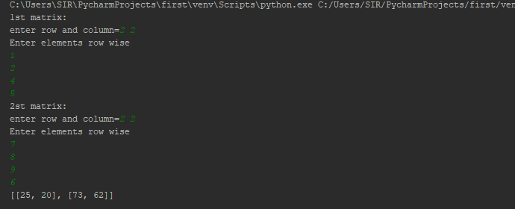

# Practical 19

**A python program to find the number of words in a string.**

ash=input('Enter the String : ')  
print ("The original string is : " +ash)  
total = str(len(ash.split(' ')))  
print ("The number of words in string are : " +total)

Output:-

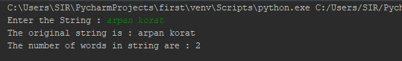

# Practical 20

**A python program to insert a sub string in a string in a particular position.**

mainstr=input('Enter main string : ')  
sub=input('Enter sub string : ')  
N=int(input('Enter the position where you want to insert : '))  
print("The original string : " +mainstr)  
print("The add string : " +sub)  
  
finalstr = list(mainstr)  
finalstr.insert(N,sub)  
finalstr = ''.join(finalstr)  
  
# print finalstrult  
print("The final string after performing addition : " + str(finalstr))

Output:-

